**PLUMBAPP Context Diagram**

This diagram is designed to make details and boundaries of the system known to the different stakeholders of a project pointing out the flow of information between the system and external components.

The diagram below represents PLUMBAPP’S context diagram:

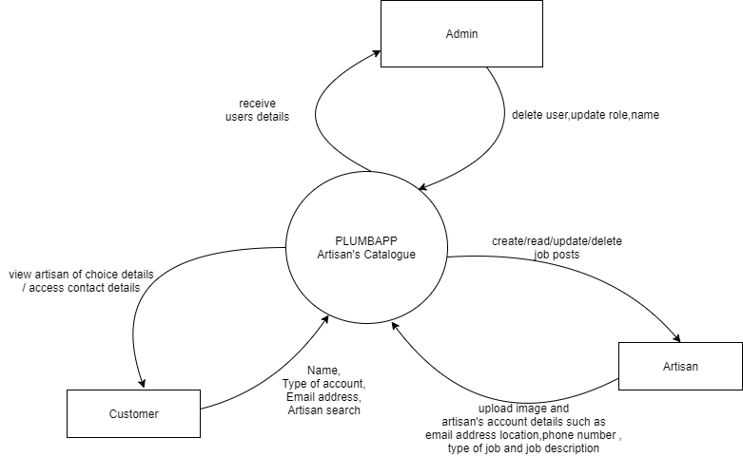

Figure 1: PLUMBAPP Context diagram

**PLUMBAPP Entity Relationship Diagram**

This is a type of a structural diagram that is used in database design to give a visual snapshot of how entities relate to each other. The figure below represents PLUMBAPP’S entity relationship diagram.s

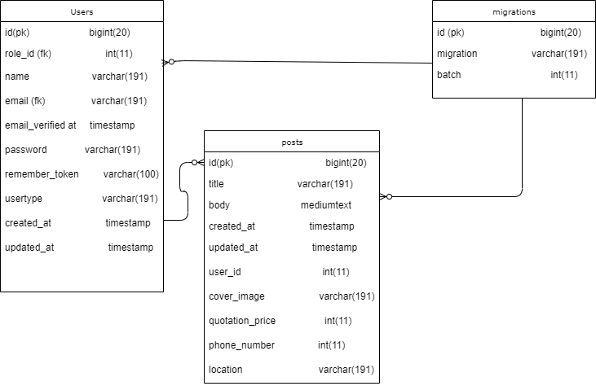

Figure : PLUMBAPP Entity Relationship Diagram

**PLUMBAPP Class Diagram**

In software engineering, a class diagram in the Unified Modelling Language is a type of static structure diagram that describes the system’s structure by showing the classes, attributes operations methods and relationships. The figure3 below is PLUMBAPP’s class diagram:

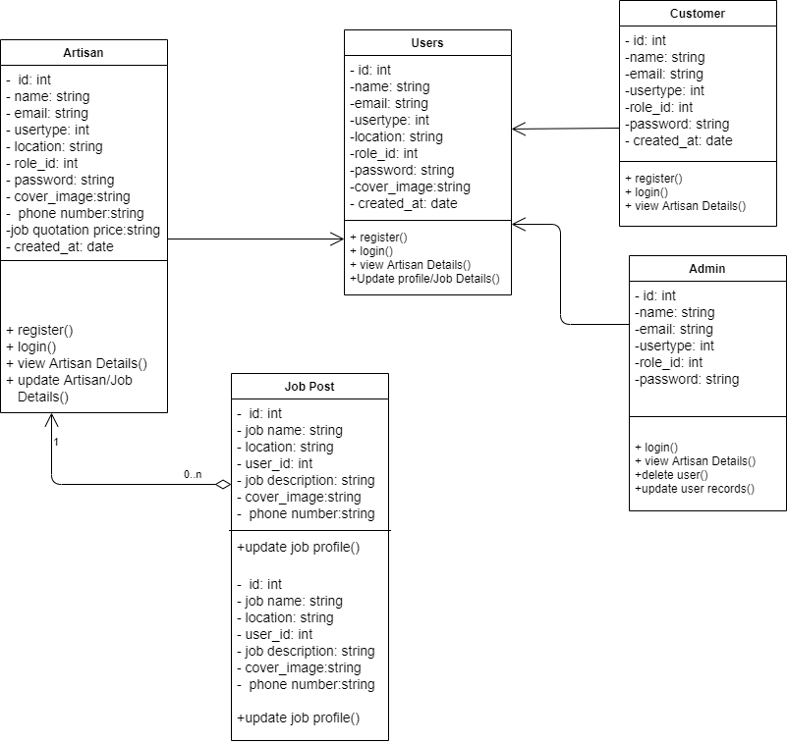

Figure 3: PLUMBAPP Class Diagram

**PLUMBAPP Use Case Diagram**

This diagram provides an overview of the system users (Customers and Artisans) and some of the functionalities they can perform within the application. The diagram below represents PLUMBAPP’S Use Case Diagram.

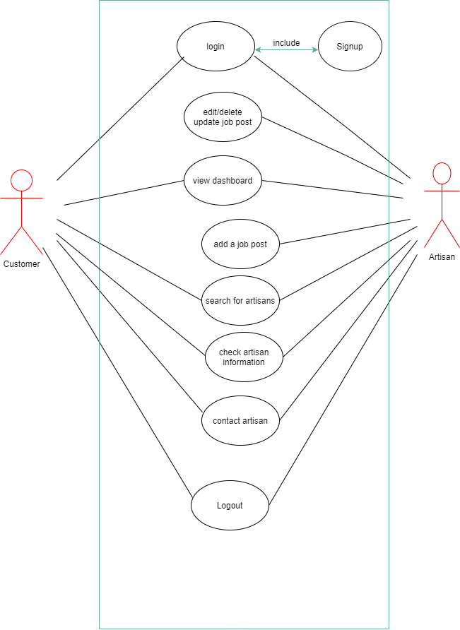

Figure : PLUMBAPP Use Case Diagrams